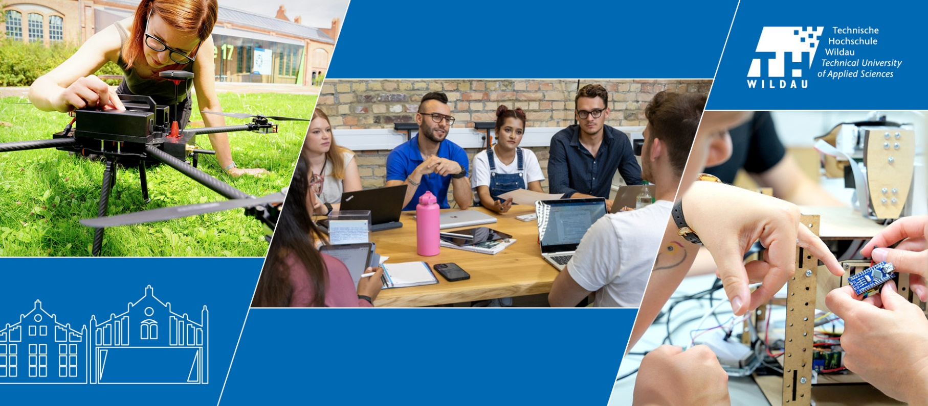

**Shaping the future together for a society worth living in - this is the vision of TH Wildau! As a university of applied sciences, we strive to support social transformations responsibly and with a strong practical focus. We bring technology and management together, turning interdisciplinary spaces into innovative learning environments and fostering creativity in our research and teaching. In the metropolitan region of Berlin/Brandenburg, our campus is renowned as a hub for connection, lifelong learning, and collaboration across diverse (disciplinary) cultures.. With its state-of-the-art facilities and 19th-century industrial architecture our campus also symbolizes what is important to us as experts and as people: we connect!**

We would like to strengthen our team in the Faculty of xxx with the following position:

**Professor (f/m/d)**(Salary grade W 2 BbgBesO)

in the field of **XY**

(reference number)

**Your areas of responsibility**

* You represent your field in teaching, applied research and knowledge transfer.
* You are present on campus and online, providing intensive support to students and conducting in praxis-oriented teaching within your field of expertise, as well as in other degree programmes, related foundational subjects, and part-time degree programmes in both German and English.
* You use innovative (digital) teaching and learning methods and are committed to developing them further.
* You conduct praxis-oriented research projects and knowledge transfer, in particular with other universities, research institutes, business and industry.
* You are involved in study reform processes and university administration duties, and support university-wide goals (including being aware of heterogeneity, promoting women in STEM subjects and actively engaging with change and complexity).
* You are involved in interdisciplinary, cross-departmental and interdisciplinary modes of study and work.

**Information and contact details**

The advertised professorship is a permanent position.

The position is to be filled at the earliest possible date and is suitable for part-time work.

**Questions about the application?**   
Appointment management   
[Maren Bauduin](https://www.th-wildau.de/personen/maren-bauduin)

**Questions about the professorship?**  
Contact the head of the appointment committee [LINK]

**Our campus**

**next to the S-Bahn**

≈ 3300 Studierende aus 60 verschiedenen Ländern

≈ 450 Beschäftigte

≈ 90 Professorinnen und Professoren

**Your profile**

* Necessary subject-specific requirements xyxyyxyxyxyxyxyx
* Required subject-specific requirements xyxyyyxyxyxyxyx
* Applicants are expected to provide evidence of relevant academic achievements, usually in the form of a doctoral degree.
* Research activities and publications according to your academic age
* Fluency in German and English
* Proof of strong didactic competence is an advantage
* Professional experience in interdisciplinary collaboration or in the context of international co-operation is advantageous
* Regional, national and international connections are desirable

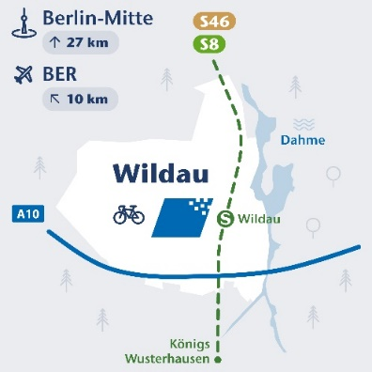

**TH Wildau in figures**

* approx. 3,300 students from 60 different countries
* approx. 450 employees
* of which approx. 90 professors
* approx 11 million third-party funds

**Your qualifications** according to § 43 Brandenburg Higher Education Act

* a completed university degree
* pedagogical aptitude
* special aptitude for academic work, usually demonstrated by a doctoral degree
* Notable accomplishments in applying or advancing scientific knowledge and methods during at least three years of professional experience, with a minimum of two years spent outside the university sector
* comprehensive skills in research management, particularly in areas with a high level of external funding or considerable personnel responsibilities

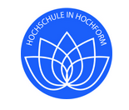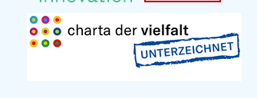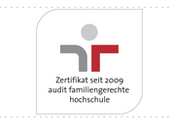

Further training and career development opportunities

The freedom of independent work with ample scope for creativity and decision-making

Wide range of health and sports activities

Family-friendly, flexible working environment

Research at one of Germany's leading universities of applied sciences in securing external funding

Comprehensive support structures for teaching, research and transfer

What we offer

We welcome all qualified applicants - regardless of gender, nationality and origin. Applicants with disabilities will be given preference if they fulfil the criteria and qualification requirements. .

We would like to increase the proportion of female professors at our university and therefore expressly encourage women to apply. We also welcome applicants with children - TH Wildau is certified as a family-friendly university.

To allow for consideration of [academic age](https://www.th-wildau.de/hochschule/beauftragte/berufungsmanagement/akademisches-alter), we ask all applicants to indicate the five most relevant publications for this professorship in their list of publications.

**We look forward to receiving your application!**

Legal notice   [Privacy](https://www.th-wildau.de/datenschutz)         [Accessibility](https://www.th-wildau.de/barrierefreiheit)

**How to apply**

Please apply by dd.mm.yyyy, quoting the reference number provided. Please submit your application online via our application portal to

**President**   
of Technische Hochschule Wildau – Technical University of Applied Sciences,   
Hochschulring 1  
15745 Wildau

*Visit us also on*

